DSA06 – DATA HANDLING AND VISUALIZATION

ACTIVITY REPORT
Activity 5: Normality Detection using Q-Q Plots
Submitted by
Detail | Information
Name | ROHAN P T
Register No. | 192424112
Roll No. | 28
Slot | C
Course | DSA06 – Data Handling and Visualization
Tools Used | R (ggplot2: stat_qq, stat_qq_line)
Date | 15.10.2026

1. AIM
The aim of this activity is to judge whether four data sets are normally distributed by reading their normal quantile–quantile (Q-Q) plots, to name the shape of every departure from normality that is found, to support each decision with evidence visible in the plot, and to propose a suitable remedy for the data set that fails the normality check most seriously.

2. BACKGROUND: HOW TO READ A Q-Q PLOT
A normal Q-Q plot compares the ordered sample values (sample quantiles, vertical axis) with the values that a perfectly normal distribution would be expected to produce (theoretical quantiles, horizontal axis). In the charts of this activity, each dot is one observation and the red-orange line is the reference line of perfect normality drawn by stat_qq_line(). If the data are normal, the dots lie close to this line along its whole length.
The pattern of the departure from the line reveals the shape of the distribution:
- Normal: dots follow the line closely from the lowest to the highest quantile, with only small random scatter at the two ends.
- Right-skewed: the upper tail curves above the line while the lower tail stays flat and bunched near or above the line (a long right tail, a short left tail).
- Left-skewed: the mirror image; the lower tail drops below the line while the upper tail is compressed.
- Heavy-tailed: an S-shape in which the lower tail falls below the line and the upper tail rises above it, because extreme values are more extreme than a normal distribution allows.
- Light-tailed: the opposite S-shape; the lower tail lies above the line and the upper tail lies below it, because the data stop short of normal extremes.
- Bimodal: a visible step or kink in the middle of the plot with flat stretches either side of the gap.
- Normal with outlier(s): most dots follow the line, but one or two isolated points sit far away from it.

3. PART A: ANALYSIS OF THE FOUR CHARTS (16 MARKS)

3.1 Chart 1: Plant Height (cm), n = 100
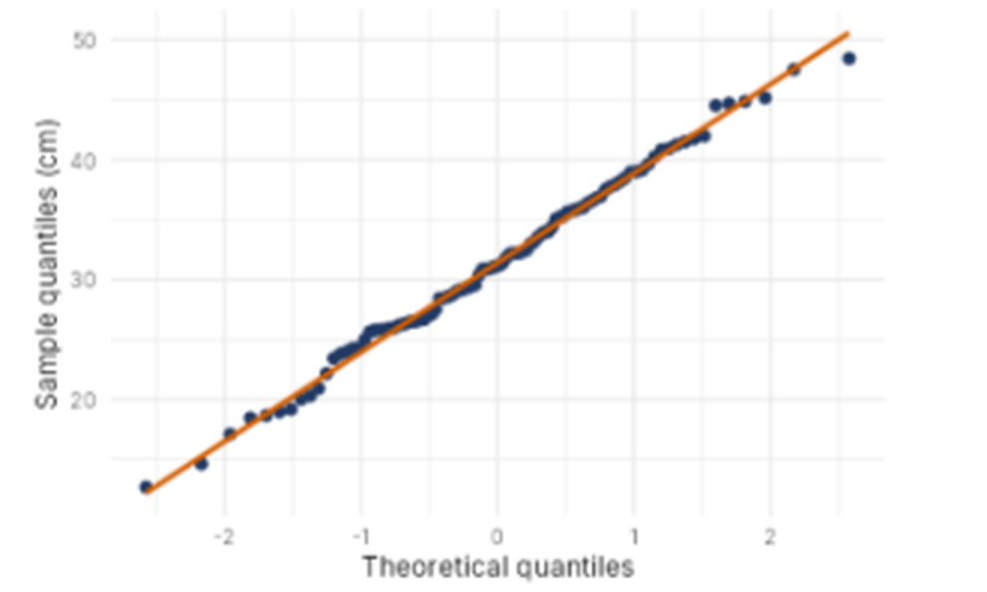
Figure 1: Normal Q-Q plot of plant height (cm), n = 100
Decision: Normal. Shape: Normal.
The dots track the reference line almost perfectly from the smallest value (about 18 cm) to the largest (about 48 cm). The points in the middle of the plot lie directly on the line, and the only small wobbles occur at the two extreme ends, which is ordinary sampling noise for a sample of 100. There is no systematic curvature, no S-shape, no step in the middle, and no isolated point that stands apart from the rest. Because the spread of sample quantiles grows at the same rate as the theoretical quantiles, the data behave as if they were drawn from a normal distribution, so mean-and-SD methods are appropriate.

3.2 Chart 2: Plant Height (cm), n = 80
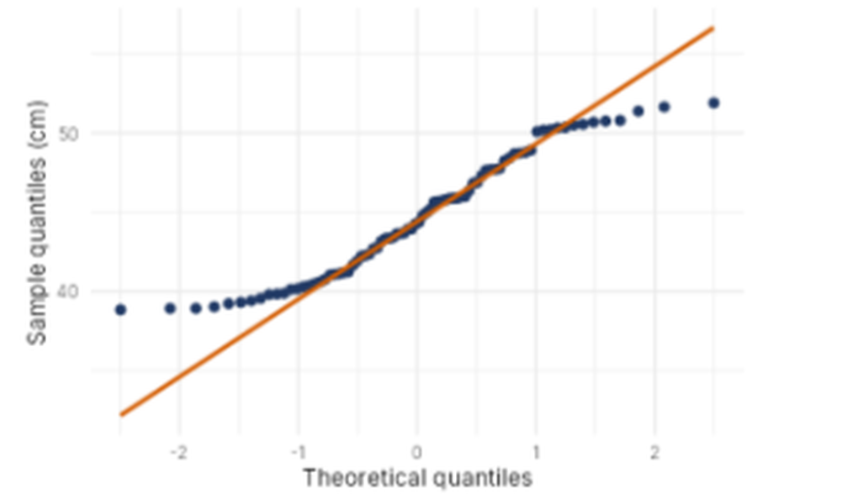
Figure 2: Normal Q-Q plot of plant height (cm), n = 80
Decision: Not normal. Shape: Light-tailed.
The central part of the plot (roughly between theoretical quantiles −1 and +1) follows the line, but both tails depart from it in the pattern typical of light tails. At the lower end, the dots form a flat run near 39–40 cm and sit above the reference line, which continues to fall towards about 30 cm. At the upper end, the dots level off near 50–52 cm and lie below the line, which keeps climbing to about 56 cm. The overall outline is an S-shape: lower tail above the line, upper tail below it. This means the smallest and largest plants are not as extreme as a normal distribution with the same mean and SD would predict, so the data are bounded or truncated at both ends. The flat clusters at the ends suggest that many plants have nearly the same height at the extremes (for example, a natural or measured limit), which a normal curve does not allow.

3.3 Chart 3: Lab Experiment Duration (minutes), n = 30
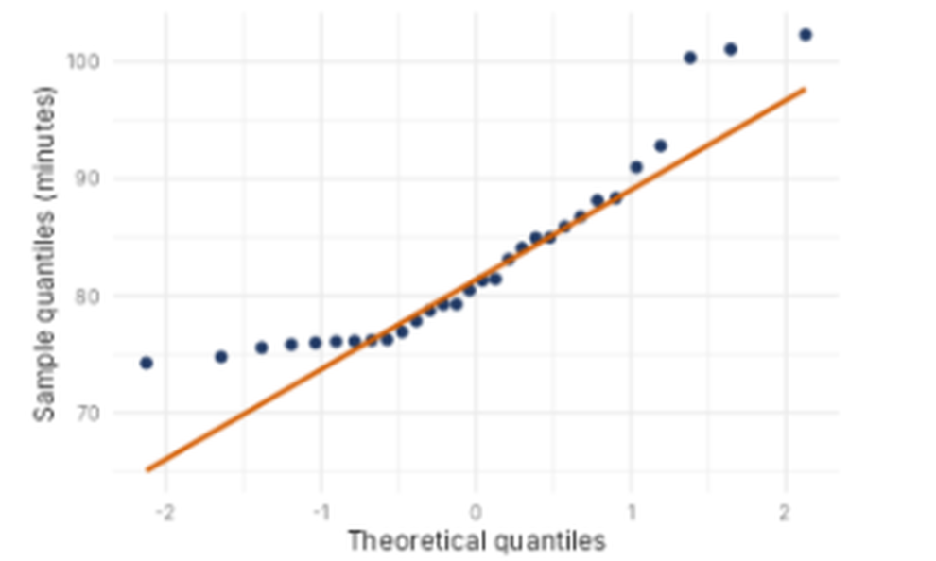
Figure 3: Normal Q-Q plot of lab experiment duration (minutes), n = 30
Decision: Not normal. Shape: Right-skewed (with high outliers in the upper tail).
In the centre of the plot, between theoretical quantiles of about −0.5 and +1, the dots lie on the line. The two tails, however, depart in opposite directions from what a normal distribution requires. The lower tail is flat: values from roughly −1.5 to −0.5 are all about 75–76 minutes and lie above the line, so the shortest durations are bunched together and cannot go as low as the line predicts. The upper tail curves sharply upward: the last five or six points rise above the line, and the three largest (about 100, 101 and 102 minutes) are far above it. A compressed lower tail together with a stretched upper tail is the signature of a right-skewed distribution, where a few unusually long experiments pull the mean upwards.

3.4 Chart 4: Commute Time (minutes), n = 60
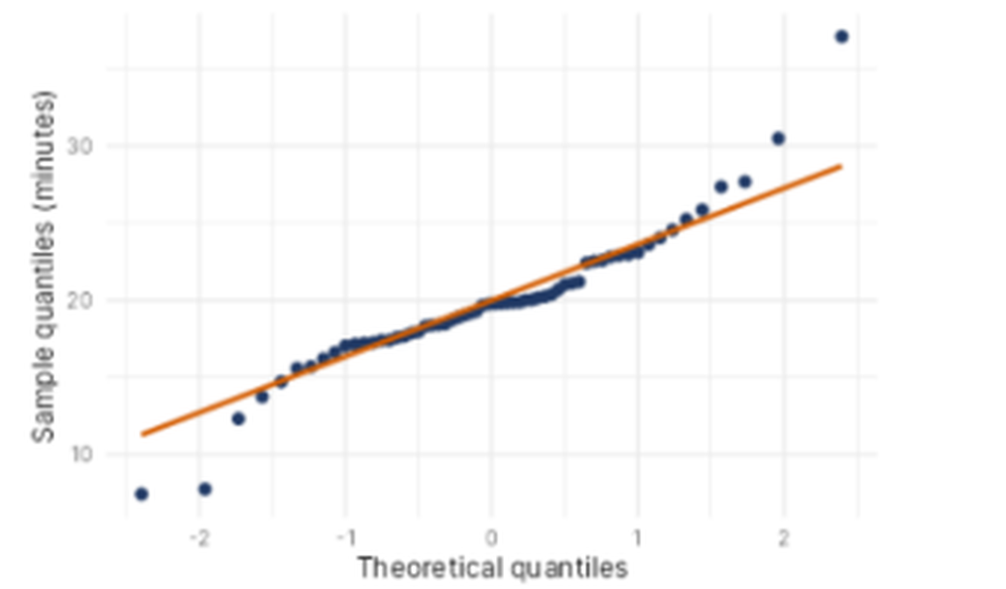
Figure 4: Normal Q-Q plot of commute time (minutes), n = 60
Decision: Not normal. Shape: Heavy-tailed.
The middle of the plot follows the reference line reasonably well, with the points between about 14 and 22 minutes close to it. Both ends, however, peel away from the line in the S-shape that marks heavy tails. At the lower end, the first three or four points (about 7–12 minutes) fall below the line. At the upper end, the points rise above the line and become more extreme, reaching about 27, 28, 30 and finally 37 minutes for the largest observation. Therefore the unusually short and unusually long commutes are more extreme than a normal distribution would produce, which means extreme values occur more often than a normal model expects. The very large point at the top-right also makes the upper tail longer than the lower tail, so a few exceptional journeys (for example, traffic disruption) may be contributing.

3.5 Summary of Part A
Chart | Normal? | Shape | Key evidence in the plot
1 | Yes | Normal | Dots lie on the line along its whole length; no curvature or outliers.
2 | No | Light-tailed | Lower tail above the line, upper tail below the line (S-shape); flat clusters at both ends.
3 | No | Right-skewed | Flat, bunched lower tail above the line; three highest points (about 100–102) far above the line.
4 | No | Heavy-tailed | Lowest points below the line and highest points (up to 37) above it (S-shape).

4. PART B: DEPARTURE AND REMEDY

B1. Departure and remedy for Chart 3
Departure: Chart 3 departs from normality by being right-skewed. Its lower tail is compressed and lies above the reference line, and its upper tail is stretched, with the three largest values (about 100–102 minutes) lying well above the line.
Remedy: Apply a log transformation to the duration data (for example, log(duration)) before using mean-and-SD methods. A logarithm shrinks large values much more than small ones, pulling in the long right tail and spreading out the bunched lower values, which makes the distribution more symmetric. After transforming, draw the Q-Q plot again; if the dots now follow the line, mean-and-SD methods can be used on the transformed scale. If a few extreme durations still stand out, a robust summary (median and IQR) can be reported instead, and the three unusually long runs should be checked for recording or procedural errors before they are removed or kept.

B2. Completing the Q-Q plot code
A normal Q-Q plot with its reference line for the data frame df and the column value is drawn by adding the point layer and the line layer to the ggplot object:
ggplot(df, aes(sample = value)) + stat_qq() + stat_qq_line()
Blank 1: stat_qq() – plots the sample quantiles against the theoretical normal quantiles as points.
Blank 2: stat_qq_line() – adds the red reference line through the first and third quartiles that represents perfect normality.

5. CONCLUSION
Only Chart 1 (plant height, n = 100) can be treated as normal, because its points follow the reference line throughout. Chart 2 is light-tailed, Chart 3 is right-skewed, and Chart 4 is heavy-tailed, so none of these should be analysed with mean-and-SD methods without first checking the departure. For Chart 3, a log transformation is the first remedy to try, followed by a robust summary if the extreme values persist. The activity shows that a Q-Q plot gives more information than a single test statistic, because the position and direction of the departure identify the shape of the problem and point to the appropriate correction.

